# CS 255 System Design Document Template

## UML Diagrams

### UML Use Case Diagram

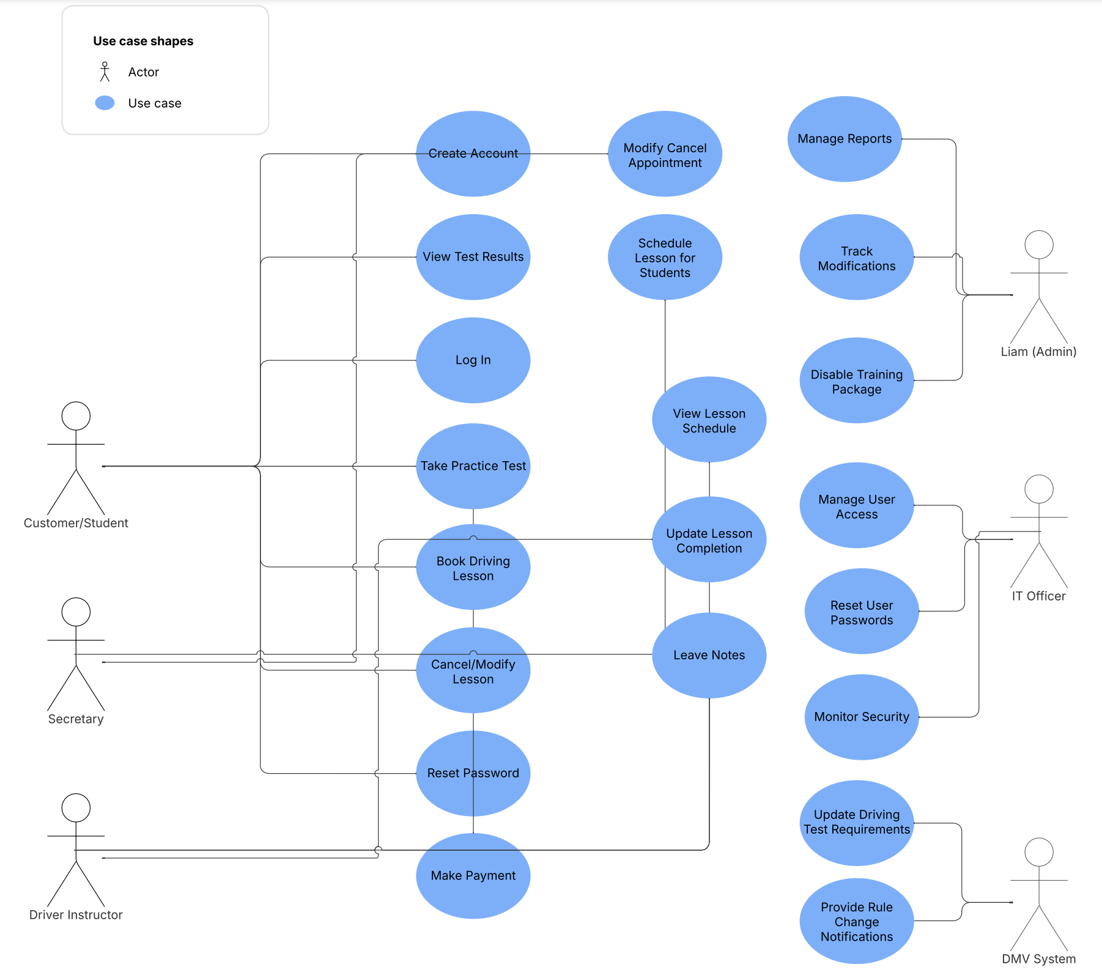

### UML Activity Diagrams

***USER CREATES ACCOUNT***

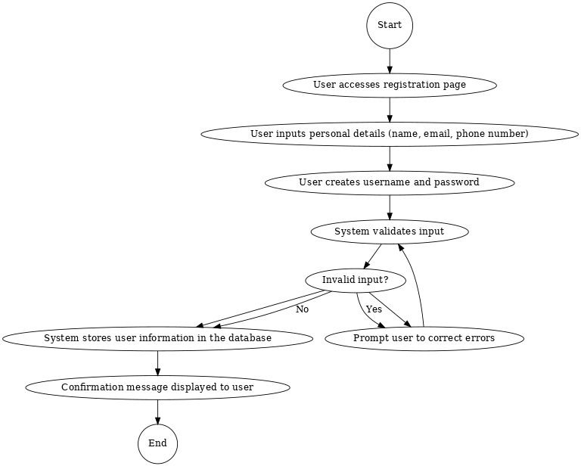

***USER BOOKS LESSON***

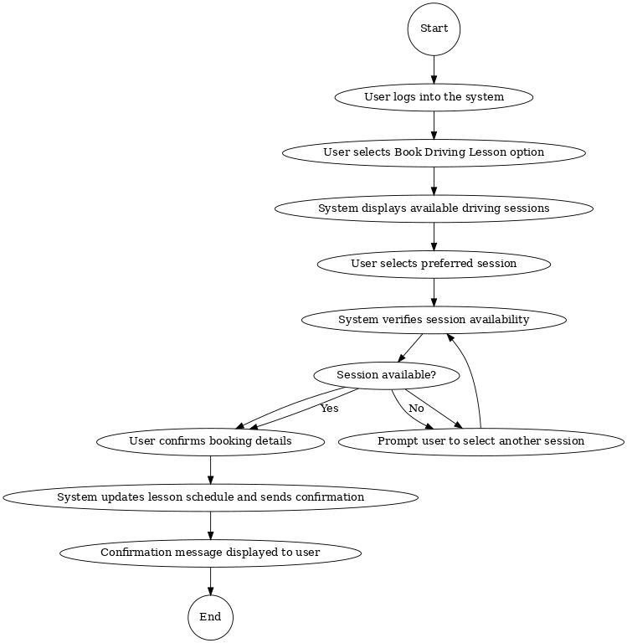

### UML Sequence Diagram

***USER BOOKS DRIVING LESSON***

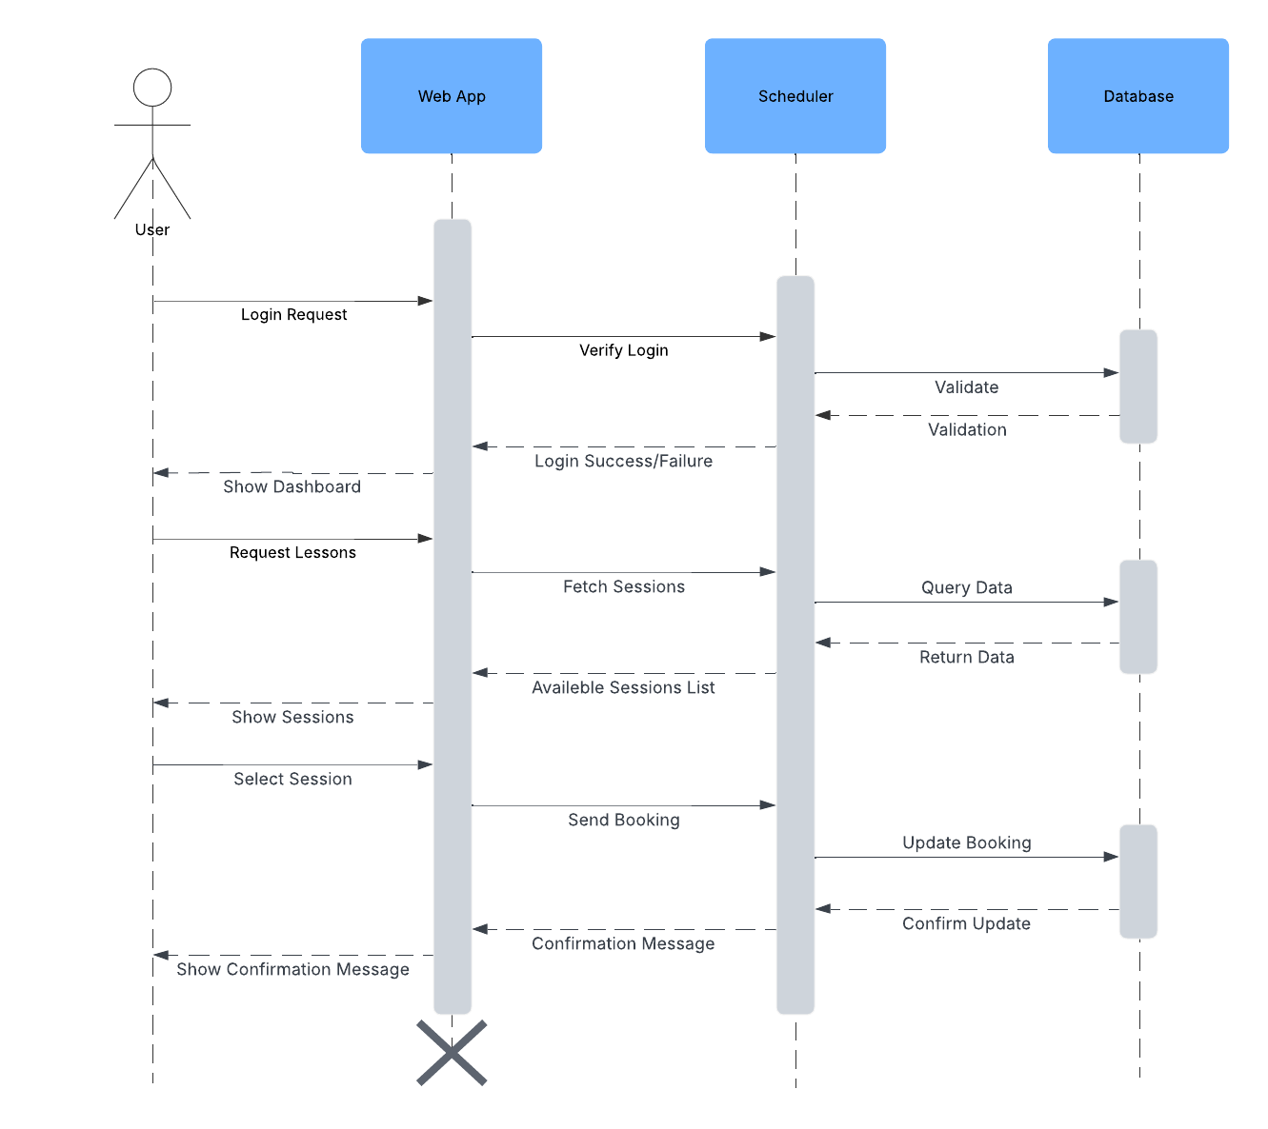

### UML Class Diagram

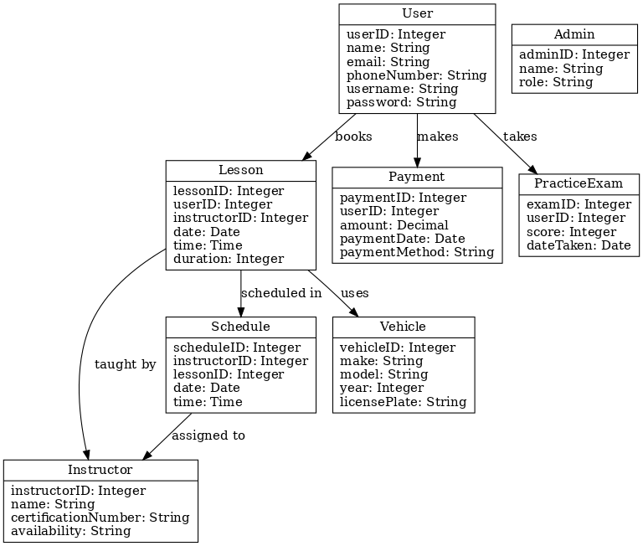

## Technical Requirements

#### **Hardware Requirements:**

* **Server:** Cloud-based server (AWS, Azure) with scalable resources (minimum 4 vCPU, 16GB RAM)
* **User Devices:** Any internet capable device (PC, tablet, smartphone)
* **Network:** Reliable internet connection with secure protocols (HTTPS)

#### **Software Requirements:**

* **Operating System:** Linux (Ubuntu) for server hosting
* **Database:** PostgreSQL for relational data storage
* **Backend:** Node.js with Express.js framework
* **Frontend:** HTML5, CSS3, JavaScript (React.js preferred for dynamic UI)
* **APIs:** RESTful API for communication between frontend and backend
* **Practice Exam Integration:** JavaScript library for exam delivery and scoring
* **Payment Processing:** Integration with Stripe API for secure transactions

#### **Tools:**

* **Lucidchart:** For creating UML diagrams
* **GitHub:** For version control
* **Visual Studio Code:** As primary code editor
* **Postman:** For testing API endpoints

#### **Infrastructure:**

* **Hosting:** AWS Elastic Beanstalk or Azure App Services
* **Security:**
  + SSL Certificates for secure data transmission
  + OAuth 2.0 for user authentication
  + Role-based access control for user permissions
  + Data encryption for sensitive user information
  + Account locking after 5 unsuccessful login attempts
* **Backup:** Automated daily database backups
* **Monitoring:** AWS CloudWatch or Azure Monitor for system health checks
* **Accessibility:** Responsive design for mobile and desktop platforms
* **Scalability:** Cloud infrastructure to accommodate user growth
* **DMV Integration:** Automated sync with DMV updates for compliance